**Testing Of Program**

**Entering Customer Details:**

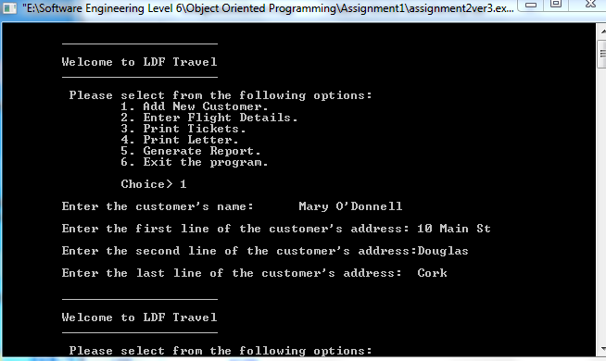

**Error Checking for Flight Input:**

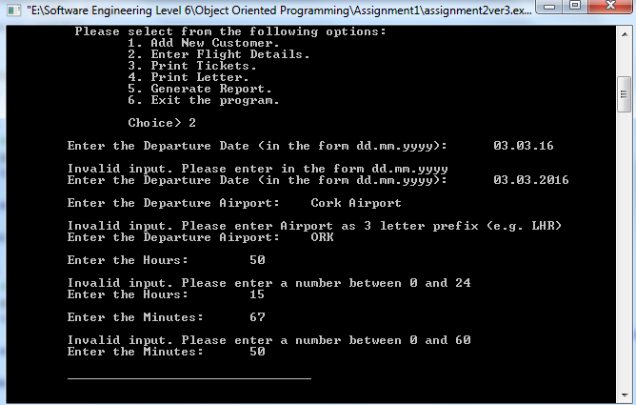

**Method called again for Second Flight:**

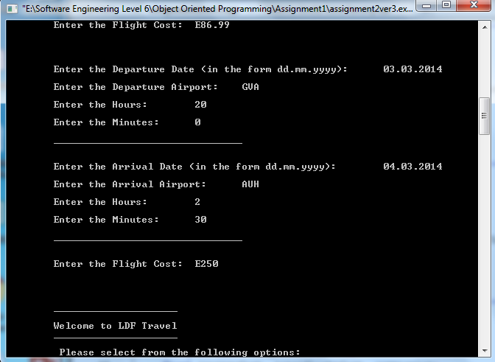

**Format of Boarding Passes:**

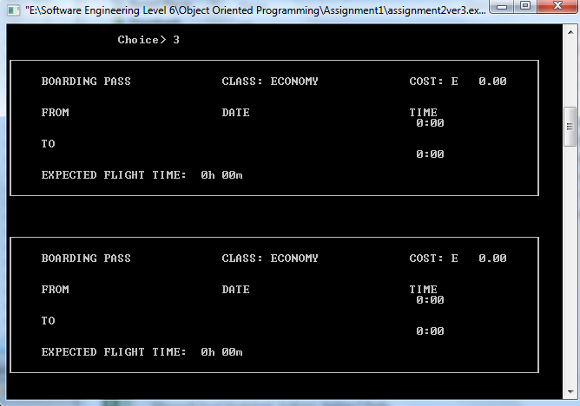

**Format of Summary Letter:**

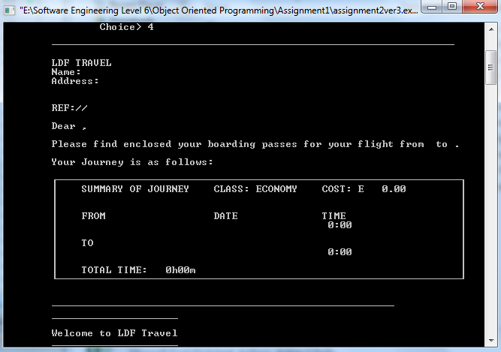

**Format of End of Day Report:**

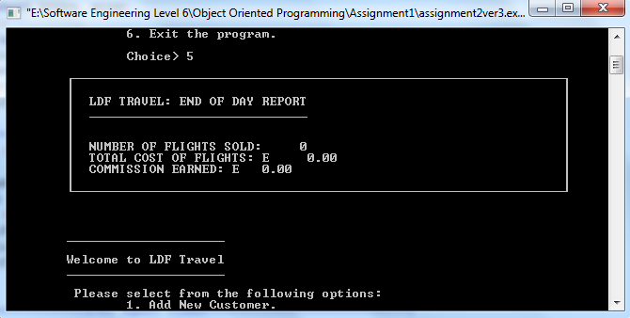

**Boarding Passes without Working Flight Time:**

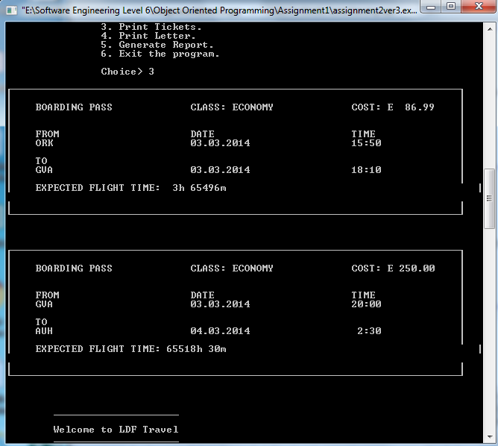

**Summary Letter without Working Journey Time:**

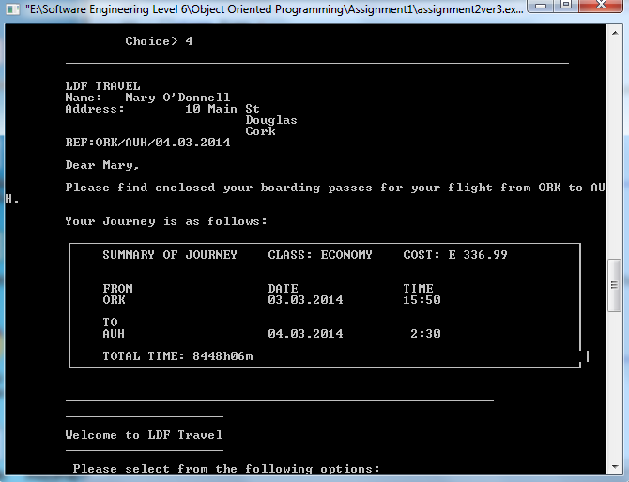

**Working Report:**

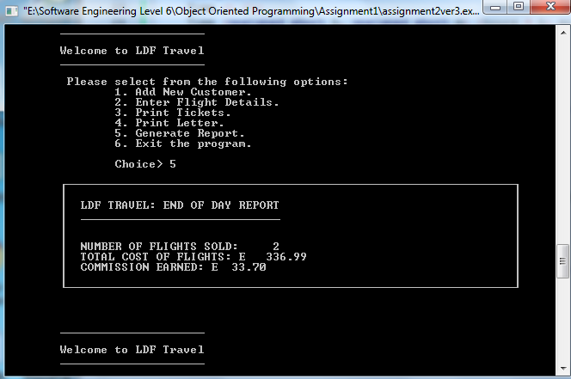

**Note:**

As I never managed to get the operators overloading properly for the Time class objects I felt it unnecessary to include more test Data.